**V****IRTUAL ASSISTANT WITH SPEECH RECOGNITION WITH SEMIOTIC INSPECTION METHOD USING MOBILE APP**

A Capstone Project

Presented to the  
Faculty of the Department of Information Technology

College of Engineering

Eastern Visayas State University

Tacloban City

In Partial Fulfillment

of the Requirements for the Degree

Bachelor of Science in Information Technology

By

Arlene P. Amado

Jason Joseph P. Holanda

Ritze M. Lianza

June 2025

**APPROVAL SHEET**

The Capstone Project Study entitled **VIRTUAL ASSISTANT WITH SPEECH RECOGNITION WITH SEMIOTIC INSPECTION METHOD USING MOBILE APP** prepared and submitted by Arlene P. Amado, Jason Joseph P. Holanda, and Ritze M. Lianza in partial fulfillment of the requirements for the degree of BACHELOR OF SCIENCE IN INFORMATION TECHNOLOGY has been examined and is recommended for acceptance and approval for **FINAL DEFENSE**.

**GIOVANNI N. DE LOS SANTOS, MSIT**

Adviser

APPROVED by the members of the Evaluation Panel on FINAL DEFENSE with a grade of

PASSED.

|  |  |
| --- | --- |
| **CAPSTONE PROJECT COMMITTEE** | |
| **SARAH JANE L. CABRAL, MIT**  Panelist | **JESSIE R. PARAGAS, DIT**  Panelist |
| **WIT EXCELSIOR T. PAÑA, MSIT**  Lead Panelist | |

Accepted and approved in partial fulfillment of the requirements for the degree of BACHELOR OF SCIENCE IN INFORMATION TECHNOLOGY.

**VINYL H. OQUIÑO, PhD**

Dean, College of Engineering

**JESSIE R. PARAGAS, DIT**

Head, IT Department

December 6, 2024

Date of Defense

**ACKNOWLEDGEMENT**

This capstone project was completed successfully thanks to the efforts and encouragement of many people, to whom we are truly grateful. First and foremost, we sincerely thank our adviser, Mr. Giovanni N. de los Santos, for his unwavering guidance, support, and encouragement throughout the endeavors in the making of this project. The knowledge, insights, and helpful feedback proved to be very beneficial in the making of this study.

We would also like to express our gratitude to Dr. Jessie R. Paragas, Prof. Wit Excelsior T. Paña, Prof. Raymond M. Daylo, & Prof. Sarah Jane L. Cabral, for their time and effort in reviewing our work and providing valuable feedback and suggestions. Their insightful comments and recommendations have enabled us to improve the quality of this capstone project.

We would also like to mention the unwavering support, inspiration, and encouragement we have received from friends, family, and peers, and to them we are also truly grateful, as well as the respondents of this project. It was also of their support, love, feedback & understanding that we sourced our motivation and inspiration to brave the storms that we faced in the making of this capstone project.

We would also not forget Dr. Lyra K. Nuevas for supervising & guiding us and our entire section, all of our work would have been for naught without her. She is also the reason for the professional level quality of all our work.

**A. P. A.**

**JJ. P. H.**

**R. M. L.**

**TABLE OF CONTENTS**

**Page**

**TITLE PAGEi**

**APPROVAL SHEETii**

**ACKNOWLEDGEMENTiii**

**TABLE OF CONTENTSiv**

**LIST OF TABLESvi**

**LIST OF FIGURESvii**

**ABSTRACTviii**

**Chapter I - INTRODUCTION1**

Objectives of the Study3

Scope and Delimitations3

Significance of the Project3

**Chapter II - THEORETICAL FRAMEWORK5**

Review of Related Literature5

Concept of the Study10

Definition of Terms12

**Chapter III - OPERATIONAL FRAMEWORK15**

Materials15

Software15

Hardware17

Data Source17

System Environment18

**Page**

Locale18

Population of the Study19

Description of the Present System19

Limitation and Drawback of the Present System20

Methods21

Agile Development Process21

Gantt Chart25

Data and Process Modeling27

Programming Development35

Evaluation37

**Chapter IV - RESULTS AND DISCUSSION38**

**Chapter V - SUMMARY, CONLUSIONS, AND RECOMMENDATIONS45**

Summary45

Conclusions47

Recommendations48

**REFERENCES49**

**APPENDICES56**

**CURRICULUM VITAE69**

**LIST OF TABLES**

**Table Page**

**3-1** System Software15

**3-2** Specifications of Hardware used in Development17

**3-3** Data Source18

**3-4** Gantt Chart26

**4-1** Respondents of the Study41

**4-2** Functional Suitability of the Mobile Virtual Assistant App41

**4-3** Performance Efficiency of the Mobile Virtual Assistant App42

**4-4** Usability of the Mobile Virtual Assistant App43

**LIST OF FIGURES**

**Figure Page**

**2-1** Conceptual Framework of the Study11

**3-1** Locale Map of Tacloban City Adventist Elementary School Incorporated19

**3-2** Agile Model21

**3-3** Database Schema22

**3-4** Context Diagram28

**3-5** Data Flow Diagram28

**3-6** System Flowchart29

**3-7** Use Case Diagram30

**3-8** System Architecture30

**3-9** Mobile Application31

**3-10** Login32

**3-11** Dashboard32

**3-12** Questions Page33

**3-13** Unanswered Questions Page33

**3-14** Users Page34

**3-15** Logs Page34

**3-16** Help Page35

**4-1** Speech Recognition Feature38

**4-2** Auto-translate Feature39

**4-3** Language Detection Feature40

**ABSTRACT**

**Amado, Arlene; Holanda, Jason Joseph; and Lianza, Ritze “Virtual Assistant with Speech Recognition with Semiotic Inspection Method Using Mobile App”** (Eastern Visayas State University, December 2024, Tacloban City)

Adviser: **Giovanni N. de los Santos, MSIT**

IT- Faculty

EVSU- Tacloban City

In today’s fast-evolving digital landscape, the need for efficient and accessible administrative processes, particularly in the education sector, has become increasingly critical. This study introduces a Virtual Assistant with Speech Recognition utilizing a Semiotic Inspection Method via a Mobile Application, a pioneering smart mobile assistant designed to transform how the registrar's office at Tacloban CityAdventist Elementary School manages inquiries. This innovation addresses the current lack of an online system for handling administrative queries, tackling challenges such as manual processing, increased workloads, limited service availability, and communication barriers with parents and guardians.

To resolve these issues, the proposed virtual assistant was developed, providing 24/7 accessibility and significantly enhancing operational efficiency. The system leverages speech recognition technology combined with a semiotic inspection method to process and respond to user inquiries effectively. A search and matching algorithm that identifies keywords and phrases relevant to user queries, offering real-time responses through voice or text input. By integrating a predefined database, the virtual assistant ensures accurate and timely assistance.

The system was developed using the Agile methodology, focusing on iterative improvements to address user needs and minimize errors. Key features include robust keyword matching, real-time interaction, and automated processing, all aimed at reducing administrative burdens and improving user satisfaction.

Evaluation of the system was conducted based on ISO 25010 standards, yielding remarkable results: functional suitability scored 4.25, performance efficiency achieved 4.31, and usability was rated at 4.36. These outcomes underscore the system’s exceptional reliability and effectiveness.

This study highlights the virtual assistant’s potential to revolutionize administrative operations in educational institutions globally, offering scalability, enhanced communication between schools and families, and a streamlined approach to handling inquiries, ultimately fostering a more connected and efficient educational ecosystem.

*Keywords:* Smart Mobile Assistant, Virtual Assistant, Speech Recognition, Semiotic Inspection Method

Chapter I

## INTRODUCTION

In this era of a fast-paced digital world, the need for efficiency and accessibility has never been more critical. One of those present at the vanguard of this technological revolution are virtual assistants (VAs), who are revolutionizing the way people manage daily tasks, engage with technology, and conduct business. Software agents that can carry out operations or provide services in response to queries or commands are known as virtual assistants. The use of virtual assistants has increased dramatically in a number of fields in recent years. Notably, education is a crucial field where the use of virtual assistants is growing.

Tacloban City Adventist Elementary School Incorporated, a school established by the local Seventh-day Adventist Church community in Tacloban City, Philippines does not possess any sort of online system in the workforce, specifically the registrar, as found by the researchers. With that in mind, the researchers propose a project that develops a virtual assistant that can be a part of the registrar’s work force of the school. In recent data gathering, the researchers found that the school registrar does not possess any kind of online system that can aid the school registrar. Similar to the context of Ghanaian higher education institutions, the position of a traditional school registrar suffers from several drawbacks, such as increased workload and stress due to high student-staff ratio leading to overwhelming inquiries. Another drawback are human errors that further decrease overall efficiency, and a traditional registrar has limited availability, meaning it does not operate 24/7 (Essel, Vlachopoulos, Tachie‑Menson, Johnson, & Baah, 2022). The researchers also found that some parents or guardians express inquiries in different languages due to having slight difficulty in expressing concerns or that the parents or guardians have a preferred language to speak, which then sometimes lead to miscommunication between the registrar and parents or guardians, this is a similar problem found from a similar study by (Duguleană, Briciu, Duduman, & Machidon, 2020). Also, the researchers foresee accents, tone, and pitch of the users’ voice input is a plausible problem that the proposed project could face, as it is a given that not all people speak in the same manner as others, as stated by (Wang, 2020), language, accent, tone, and pitch is shaped by social humanities; therefore, it is impossible to ensure complete uniformity. Whether the substance of an object is reached, the explanation is rational and thorough, or the language is conventional and scientific. These shortcomings may have an effect on the registrar office's overall efficacy and caliber, which in turn may have an impact on the experience of parents or guardians.

The researchers believed that providing the school registrar of the school a virtual assistant is of great benefit, and it is also especially true since parents or guardians alike have to tediously create learning objectives, query for sections and related schedules, ask about designated teachers, know classroom locations, and among other things. Many parents or guardians do not bring up these issues when the parents or users do not receive assistance and encouragement (Mekni, Baani, & Sulieman, 2020). Furthermore, in adding the speech recognition feature, the semiotic inspection method must also be integrated, as it is able to alleviate the problem of accents, tone, and pitch. Virtual assistants can increase productivity by lowering labor costs, reducing crowds at the help desk, and offering 24/7 support. Users can use laptops or smartphones to communicate with the virtual assistant on the internet. Pupils ask various questions in plain language about admissions information, and both are able to provide accurate answers. Users can easily access the proposed application, which responds to users at any time and from any location (Kumari, Naikwadi, Akole, & Darshankar, 2020). Additionally, since it is a given that the ratio of staff-to-students is high in every school, the number of students and parents that the school registrar has to entertain is simply too high.

**Objectives of the Project**

The study project was developed using a mobile app called: Virtual Assistant With Speech Recognition With Semiotic Inspection Method Using Mobile App that possesses the corresponding features to provide utmost convenience to users.

The project specifically:

1. Implemented a Speech Recognition feature with semiotic inspection method.
2. Implemented an auto-translate function from English to Tagalog.
3. Implemented a language detection function in the system.
4. Evaluated the system using ISO 25010 Software Standard.

**Scope and Delimitations of the Project**

The project was developed using a mobile virtual assistant app using Android OS accustomed only to the registrar of the school. The project aimed to have a speech recognition feature that can detect English or Tagalog. The project aimed to have a database server that is available 24/7 and a web-based admin. The project aimed to have an auto-translate function. The system is only able to aid the registrar in answering inquiries like FAQs. Taglish (Tagalog mixed with English) queries are answered with English answers. Integrated an API and a Plugin that enables the system to reach the objectives.

The project does not support iOS. Also, the project does not cover the official records or any confidential information that is held by the registrar. The answers given to the mobile users are dependent on tags pre-defined by the staff or admin. The system is not A.I. based.

**Significance of the Project**

The integration of a virtual assistant in the registrar’s office of the school holds a great deal of significance. The project can reduce the workload of the registrar by providing aid in answering the inquiries of the parents or guardians and provide utmost convenience to the parents or guardians. The following are the stakeholders of the project:

**School Administration**. This project could help in reduced the need for additional administrative staff and overtime expenses. As well as providing the school with automated handling of routine tasks, freeing up staff for more strategic work.

**Registrar**. This project provides less administrative burden and allows more focus on parent/guardian or student engagement and school function.

**Parents and Guardians**. The project is of great convenience and support to parents and guardians alike as the project allows for the ability to get help and information outside of office hours and faster resolution of administrative tasks and inquiries.

**Researchers**. The project is beneficial to the current researchers of the project as it provides insight and deep understanding of the project and what it can offer to society. The project could also be of great benefit to future researchers that is tackling the same or similar study or project.

**Chapter II**

**THEORETICAL FRAMEWORK**

This chapter presents the various ideas, related literature, systems, generalization, and studies on virtual assistants with speech recognition & Semiotic Inspection Method Using Mobile App. This study focuses on whether it is feasible to develop a virtual assistant app that meets the desired objectives whilst being able to aid the registrar and the parents or guardians at the school of the school.

**Review of Related Literature**

This consists of reviews of related literature that focuses on the development of a virtual assistant app. Furthermore, this provides the gathered information as a guide to the researchers in developing the proposed system.

*Virtual Assistant*

A virtual assistant responds to messages in an organized manner, applying them based on the kind of customer support that businesses require. Structured messages are prepared answers; the company looks at the most typical procedures and dialogues, creates answers, and provides them to the user (Villegas-Ch, Garcia-Ortiz, Mullo-Ca, Sánchez-Viteri, & Roman-Cañizares, 2021). Virtual assistants are defined as software programs that can identify patterns in inputs and generate results based on those patterns. When virtual assistants are made to comprehend the needs of the system’s users, it is referred to as virtual assistants (Agarwal, Agarwal, & Gupta, 2022). Virtual assistants in the education sector can be developed to respond to inquiries about a wide range of topics, including the admissions and registration process, payment concerns, housing concerns, exam inquiries, enrollment procedures, class schedules, and much more (Onyalo, 2022). Virtual assistants are made to be able to comprehend the user’s needs and respond to them in plain language. The use of virtual assistants in education has increased significantly, with the main objective being to increase each inquirer’s knowledge, typically on a particular subject. These virtual assistant’s primary objective is to learn new information similarly to a human instructor (Han & Lee, 2022). Furthermore, virtual assistants serve as agents to improve instruction and learning. Current developments in Natural Language Processing can be attributed to the rise in the use of virtual assistants (Adamopoulou & Moussiades, 2020). Utilizing a virtual assistant is of great benefit for the registrar of the school, as it can decrease workload and stress towards the attendees of the registrar, as discovered in a similar study by (Zhang, Zou, & Cheng, 2023) where the researchers found that the virtual assistant had overall positive outcomes from academic and affective aspects.

*Natural Language Processing*

The field of natural language processing, which falls under the umbrella of linguistics and artificial intelligence, enables computers to comprehend words and sentences written in human languages. It was created to make user work easier and to fulfill the desire for natural language communication between the user and the computer (Koli, Khatter, Singh, & Kurana, 2022). In natural language processing (NLP), models, systems, and algorithms are designed and put into practice to address real-world issues related to language comprehension. Furthermore, natural language processing (NLP) covers pertinent subjects like automatic text extraction (e.g., named entities and what relationships they possess), language translation, document summarization, question answering (automated), document classification, and document clustering (Lauriola, Lavelli, & Aiolli, 2022). Furthermore, natural language processing makes use of computers that can comprehend and perform useful tasks with natural language speech or text. Many academic disciplines, including machine translation, natural language text processing and summarization, user interfaces, multilingual and cross-language information retrieval (CLIR), speech recognition, artificial intelligence and expert systems, and more, employ natural language processing (NLP) in applications (Chowdhary, 2020).

*Semiotic Inspection Method*

As it is universally understood that there can be no absolute consistency in language, accents, tone, and pitch because it is a unique sign system that is shaped by social humanities. The proposed system utilizes a semiotic inspection method in order to be able to discern accents, pitch, and tone from various users and alleviate misunderstandings between the system and users. Additionally, it has been noted that the application of semiotic analysis to virtual assistants advances the understanding of how to make virtual assistant conversations as "more human" as possible to prevent user frustration and disturbance. In contrast to a machine-centered approach, semiotic analysis accurately addresses this challenge by focusing on how humans interpret and create meaning (Dall’Acqua & Bellentani, 2023). Presently, semiotic inspection method-based virtual assistants are more communicative than graphical user interfaces. Additionally, there were noted cases in the healthcare and smart home domains, it showed how virtual assistants were still able to comprehend what message the users were trying to express despite having unclear messages (Valtolina, Barricelli, & Di Gaetano, 2020).

*Speech Processing*

Speech processing is a field dedicated to the study and application of methods for analyzing and manipulating speech signals. It includes a variety of tasks, such as text-to-speech or speech synthesis, speaker recognition (SR), and automatic speech recognition (ASR). Speech processing has become more important in the past few years because of its many uses in industries like entertainment, healthcare, and telecommunications. Statistical modeling methods, in particular Hidden Markov Models (HMMs), are noteworthy for having advanced the field significantly. Significant improvements and breakthroughs in speech processing research and development have been made possible by these models (Mehrish, Majumder, Bharadwaj, Mihalcea, & Poria, 2023). In a similar system made by (Li, Kim, Park, & Chrysostomou, 2021) The researchers put into practice a voice service that combines text-to-speech and speech-to-text capabilities. The virtual assistant uses the Automatic Speech Recognition (ASR) API, a Google speech-to-text service, to identify and transcribe user speech signals in order to understand the user's intent. The spoken language understanding service on the server-side of the virtual assistant receives these transcripts (i.e., human utterances) for additional processing, such as the identification of human intent. Additionally, the virtual assistant offers two text-to-speech options that allow the text response to be turned into an audio clip and then played back through the speaker in order to provide a response that sounds natural and human.

*Text-to-Speech and Speech-to-text*

In a similar study by (Kumar, Gupta, Shrama, Soni, & Rawat, 2024) where the researchers had a system that utilized a text-to-speech and speech-to-text API as means to efficiently convert text to speech, as well as speech to text in the virtual assistant that the researchers developed. Inspired by the works of the preceding researchers, the researchers of this study came up with a similar approach, utilizing Google Speech Recognition and Syntheses API in processing text to speech and speech to text. In another study by (Jampala, Kola, Gummadi, Bhavanam, & Pannerselvam, 2024) where the researchers utilized a Google application in developing a virtual assistant, the researchers stated the reliability and accuracy of the developed virtual assistant with the integrated Google application. Ultimately convinced by the preceding researchers, the researchers of this project decided to integrate Google Speech Recognition and Syntheses API into the system.

*Automatic Translation between English & Tagalog*

In a similar study by (Yellamma, et al., 2024) where the researchers utilized Google Translate for reliable and accurate translations in the developed system of the researchers. As for (Althobaiti, 2022) where the researchers had a system that utilized Google Translate API as an efficient way to discern offensive Arabic language and a convenient means for language detection. Additionally, the researchers found that there are many online translation services used by people and corporations alike. Few trustworthy services that employ extremely complex machine learning algorithms to translate the source text into multiple languages exist. One of these is Google Translate, which uses machine learning principles to translate languages and produces translated text quite quickly (Kolhar & Alameen, 2021). It has come to the attention of the researchers that Google Translate is trustworthy, reliable, and accurate, so the researchers integrated Google Translate in the system via automation using the Puppeteer plugin.

*Keyword Detection*

The proposed system consists of a keyword detection function to determine what pre-defined answer that is then answered to the inquiries of the parents or guardians, the keywords are labeled as tags in the database of the proposed system. With this tagging method, even if the question of the parents or guardians are grammatically incorrect, or even spelled incorrectly, the proposed system can still detect the keywords and therefore come up with the pre-defined answer, eliminating the need to tediously add exact sentence of answers for exact sentence of questions, as similarly seen in the works by (Abougarair, Aburakhis, & Zaroug, 2022). Additionally, the proposed system also counts the number of tags bound to a pre-defined answer. To put this into perspective, for example, if the database has the two pre-defined answers: “That is no longer under our jurisdiction” and “It is located right by the exit of the school”, both answers have a certain number of tags it needs to check in order for the pre-defined answer to be used as a reply to the user. The first pre-defined answer needs to check only for one tag or keyword in the user’s inquiry, for example: “Where is the school canteen?”, the tag or keyword is “Where”. If the tag or key word is present, the first pre-defined answer (“That is no longer under our jurisdiction”) is used as a reply to the user. As for the other pre-defined answer, it requires two tags or keywords, for example: “Where is the school Registrar?”, the tags or keywords are “Where” and “Registrar”, if both tags or keywords are present in the inquiry, the second pre-defined answer (“It is located right by the exit of the school”) is as a reply to the user. In a similar study by (Maylawati, et al., 2022) where the researchers utilized the Rapid Automatic Keyword Extraction (RAKE) in the virtual assistant that the researchers proposed, utilizing the RAKE method resulted in 98% overall accuracy in providing answers to certain questions of users. The RAKE method was used as an entity recognizer to determine the answer to the user. In the current researchers’ proposed system, tagging method is similar to the RAKE method, where keywords of an inquiry or question are tagged, then the aforementioned tags are bound to the pre-defined question. Another study done by (Muhtar, et al., 2021), the virtual assistant proposed by the aforementioned researchers had an overall 97% accuracy in answering certain questions of users. In a similar study by (Li & Yang, 2022), the researchers utilized Keyword Targeting where the system combined selecting and matching of keywords for better accuracy.

**Concept of the Study**

The study concept is anchored in contrasting the traditional means of face-to-face inquiries at the registrar and the enhanced capabilities offered by the virtual assistant mobile app.

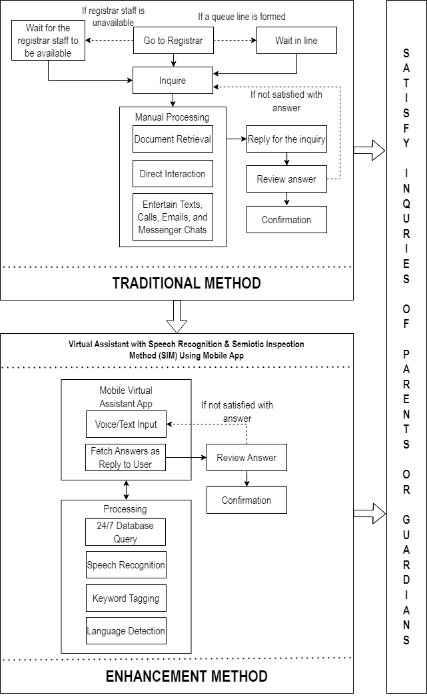

**Figure 2-1.** Conceptual Framework of the Study

Figure 2-1 are the visual depiction of the procedural steps of each stage, providing a comprehensive representation of the underlying concept, data flow, and associated processes. The Conceptual Framework of the study was illustrated from the traditional method to the enhancement method.

In the traditional method, the inquiries of parents and guardians are done face-to-face at the registrar, waiting in line indiscriminately with the other parents or guardians that might have greater concerns regarding the registrar, therefore adding to more workload and stress to the registrar’s staff, and another to point out is that the registrar is not available 24/7, and even if it were in working hours, sometimes the registrar’s staff is not available.

Therefore, the enhancement process was initiated to develop a Mobile Virtual Assistant App that aids the registrar’s office. Inquiries can be done on the Mobile Virtual Assistant App, text or voice input can be utilized by users, then the system checks the users’ inquiries for tags or keywords that are stored in the system’s database, and lastly fetch the pre-defined answer as a reply to the users in correspondence with the tags or keywords present in the users’ inquiry.

**Definition of Terms**

The following are the terminologies used in this study:

**Auto-Translate**. Automatic translation refers to the process of replacing words from one language with the counterparts in another language. It involves the use of software that can rapidly translate text with minimal human intervention (Sharabi, 2023).

It automatically translate inquiries between English or Tagalog.

**Keyword Matching.** Keyword searching algorithms are fundamental to search engines, enabling them to retrieve relevant documents or web pages based on user-input keywords (Srinam, 2024).

An Algorithm that generates responses based on pre-defines answers in the system’s database.

**Language Detection**. Is the process of identifying the language in which a given piece of text is written (Manning, 2008).

This is a method that was implemented in the proposed system to discern languages (English and Tagalog) in order for the proposed system to respond to the users in the corresponding language the users inquires in.

**Natural Language Process**. Natural Language Process enables computers and digital devices to recognize, understand and generate text and speech by combining computational linguistics—the rule-based modeling of human language—together with statistical modeling, machine learning and deep learning (Cole Stryker, 2024)

**Semiotic Inspection Method**. Evaluates and analyzes signs and symbols in a user interface to understand the meanings and effectiveness (de Souza, 2001).

In this study, the speech recognition feature of Google that was utilized possess Semiotic Inspection Method to discern tone, pitch and accent of users.

**Speech Processing**. Speech processing is the study of speech signals and the computer processing methods of these signals in digital representation (BEng(Hons), 2024).

It is to implement a speech-to-text function in the system.

**Speech Recognition**. Is the ability of a machine or program to identify words spoken aloud and convert them into readable text (Ben Lutkevich, 2021).

Speech recognition in the study is utilized in this study as to convert voice input into text input and pass it along to the database of the system, it also comes with Semitic Inspection Method.

**Tags**. A tag is a label or a keyword that can be attached to a piece of information, data, or content to help identify and organize it. It is widely used in technology, computing, programming, and communications to categorize and manage large amounts of data (Lenovo, 2024).

It utilizes the keyword matching algorithm, and it assigns the answers to the tags of a possible inquiry.

**Chapter III**

**OPERATIONAL FRAMEWORK**

The process and resources used for the study are presented in this chapter. It provides an overview of the procedures and instruments used in data collection and analysis.

**Materials**

The requirements needed for the project's development are shown and specified in detail in this section.

**Software**

The technology, software, and libraries required for building and running the system are presented and explained in this part. A number of web development tools, including HTML, CSS, JavaScript, PHP, and MySQL, are utilized in this project. These software elements are essential to the project's execution and conclusion.

**Table 3-1.** System Software

|  |  |  |
| --- | --- | --- |
| Software | Version | Description |
| Java | 8 | Used to develop the user-facing aspects of the mobile application. |
| PHP | 8.3.8 | utilize the administrator side to build a website |
| Laravel | 8 | A free and open-source PHP web framework for developing online applications |
| JavaScript | ES2015 | Used to design the front-end and prioritize mobile responsiveness |
| HTML | 5 | Used to structure the web page and its content |
| CSS | 3 | Used to design the web page’s attributes |
| NodeJS | 20.15.1 | Used for running web applications outside the client's browser. |
| MySQL  Workbench | 8.0.38 | used to create, manage, design, create, and maintain databases as well as generate SQL within an integrated development environment for the MySQL database system. |
| Android Studio | 2024.1.1 | Used to develop the mobile application's front end. |
| Visual Studio Code | 1.91.1 | The main IDE use for coding and implementing the project |
| Google Chrome Browser | 127.0.6533.43 | For building the mobile application's back end |
| Postman | 11 | used for back-end API testing |

**Hardware**

Table 3-2 highlights the materials and technologies used in the development of the application. Below are the specific requirements for the computer needed for coding, debugging, and system operation.

**Table 3-2.** Specifications of Hardware used in Development

|  |  |  |
| --- | --- | --- |
| Hardware Used  Laptop | Model | Specification |
|  | Ideapad Gaming 3 | CPU: Intel i5  RAM: 8 GB  ROM: 512 GB  GPU: RTX 3050 Ti |
| Android Device | Vivo Y20s [G] | CPU: 2.0 GHz Octa-core  RAM: 6 GB  ROM: 128 GB |

**Data Source**

Table 3-3 is an overview of the data sources used in this study is provided in this part, together with information on the significance and the collection of procedures used.

**Table 3-3.** Data Source

|  |  |  |
| --- | --- | --- |
| Data Source | Significance | Methods |
| Current System Assessment | Identify inefficiencies and challenges | Interviews, observation |
| User Feedback and Needs Analysis | Identifies specific points and desired improvements | Surveys, feedback forms |
| Comparison with Peer Institutions | Offers insights into best practices and industry standards | Comparative analysis of institutional reports, publicly available data |
| Technology Trends and Solutions | Determines feasibility and benefits of virtual assistant | Literature review, case studies |
| FAQs Analysis | Identifies recurring inquiries and patterns | Data mining of registrar records, categorization and frequency analysis |

**System Environment**

**Locale**

The selected study site is Tacloban City Adventist Elementary School Incorporated, a school established by the local Seventh-day Adventist Church community in Tacloban City, Philippines.

**Figure 3-1.** Locale Map of Tacloban City Adventist Elementary School Incorporated

Figure 3-1 is project's borders are depicted on the map view. The school is situated at Barangay 60 Sagkahan, Tacloban City.

**Population of the Study**

This population consists of 347 individuals, there are 346 parents and guardians of students currently enrolled at the school and one personnel from the registrar’s office. These individuals are key stakeholders in the educational experience of the pupils and play a crucial role in supporting the academic and extracurricular activities of the school.

**Description of the Present System**

At the institution, the registrar's office serves as a pivotal point for students, faculty, and staff seeking information and assistance on a wide range of academic and administrative matters. Parents or Guardians typically initiate inquiries through various channels such as in-person visits, phone calls, and emails. These inquiries cover a spectrum of topics including enrollment procedures, transcript requests, fee payments, and more. Upon submission, the dedicated registrar staff members promptly engage with parents and guardians to provide personalized assistance. Addressing inquiries individually, ensuring that each client receives accurate and tailored information based on the inquirer’s specific needs. This documentation includes details such as inquiry type, client information, resolution steps, and follow-up actions if necessary. This process ensures transparency and accountability in service delivery. Feedback from parents and guardians plays a crucial role in the continuous improvement efforts. By valuing client input and using it to refine the processes, enhance service delivery, and address emerging needs effectively. The current system excels in providing personalized and human-centric assistance to clients. The direct interaction between clients and registrar staff fosters a sense of trust and reliability. Additionally, documentation practices ensure that historical data is readily accessible, facilitating informed decision-making and process refinement. The current registrar is client-focused, emphasizing personalized assistance and efficient documentation. The staff are committed to enhancing the services further through continuous improvement initiatives and exploring new technologies that align with commitment to providing exceptional client support.

**Limitation and Drawback of the Present System**

The current registrar effectively provides personalized assistance and maintains detailed documentation but faces challenges due to heavy reliance on manual processes, which can lead to delays and human errors, especially during peak periods. Dependency on office hours limits accessibility for clients, and the lack of scalable automated solutions hinders efficient inquiry management and data analysis. Variations in staff knowledge and availability also contribute to inconsistencies in service delivery.

**Methods**

This study employs an Agile methodology to develop the Virtual Assistant using mobile application. Agile software development refers to a group of software development methodologies based on iterative development, where requirements and solutions evolve through collaboration between self-organizing cross-functional teams. Agile promotes adaptive planning, evolutionary development, early delivery, continuous improvement, and encourages rapid and flexible response to change (Alliance, 2024).

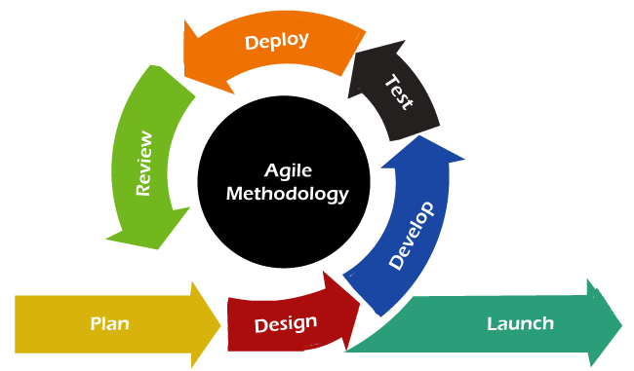

**Figure 3-2.** Agile Model

**Agile Development Process**

**Planning**

The researchers outlined the key features and goals of the Mobile Virtual Assistant App. It involves defining the project's scope, identifying stakeholders, and gathering requirements through various methods such as surveys and interviews at the school.

**Design**

The researchers set up goals to develop the main concept and added better features to the Virtual Assistant. A prototype was developed as a means to test and recognize the entire concept of the system.

**Database Schema.** The system's database schema organizes and maintains data, guaranteeing effective user interaction management, question tagging, and multilingual support. The system's overall functionality is improved by the effective data retrieval, response tracking, and content categorization made possible by this organized architecture.

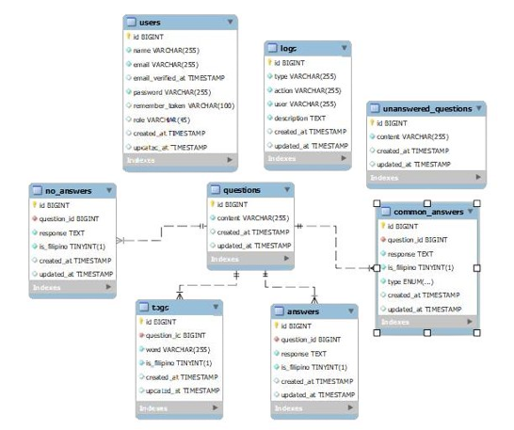

**Figure 3-3.** Database Schema

Figure 3-3 depicted the database design that can effectively manage users, questions, answers, and system interactions in order to enable a structured question-and-answer platform. In order to provide safe access control and customized user experiences, the schema is made to manage role management and user authentication. Multiple answer kinds, including user-submitted and predetermined common answers, are supported by the system, which arranges questions and responses. Content can be grouped according to language choices thanks to the integration of a multilingual capability. Additionally, questions can be labeled with pertinent keywords to enhance classification and searchability. While logs keep track of all user activities and system interactions for auditing and performance evaluation, unanswered questions are stored separately to identify pending queries in order to improve system functionality. It is a strong choice for running a dynamic knowledge-sharing platform because of its organized design, which guarantees smooth data retrieval, effective response management, and maximized user involvement.

**Development**

The researchers wrote code based on the designs and requirements of the system using Android Studio in making the mobile app. For the development of the mobile app, Java was utilized for its reliability and various features. PHP, HTML, CSS, NodeJS, Laravel, and JavaScript was utilized in the development of the web app, with the combination of the preceding coding languages, the researchers were able to develop a robust, comprehensive and dynamic web app. As for the Compilers/IDEs utilized, Visual Studio Code was utilized in developing the admin site, Android Studio was also utilized in developing the mobile app, and MySQL was utilized in developing the system’s database. Performing continuous integration, where code is regularly tested and integrated into the main codebase was also done. The researchers also integrated an API, Plugin, and Algorithms to meet the system’s requirements/objectives such as Speech Recognition and Syntheses from Google API for the language detection feature in the mobile app, the Puppeteer Plugin was also integrated into the system to automate the English to Filipino translation in Google Translate. Lastly, the String Matching Algorithm was utilized in the system in the tagging mechanics of the system, such Algorithm consists of String Comparison, Tokenization and Indexing, and Counting Algorithm, all of which are used in the process of tagging in the system.

**Testing**

The researchers as well as the stakeholders conducted multiple user testing throughout the development and testing phase of the system the system, and ultimately leading to the system’s evaluation using the ISO 25010 Standard. A total of 56 respondents took part in the testing phase of the system, including the researchers.

**Deployment**

The researchers prepared the deployment environment of the system, the researchers deployed a server for the web app side of the system, along with the system’s database, and lastly developed the APK file of the mobile app for deployment or propagation. The researchers also performed a smoke test and monitored the deployment for any issues or errors.

**Review**

The researchers conducted a sprint review meeting to showcase the completed work to stakeholders. The researchers also gathered feedback on the system’s performance from the stakeholders and reviewed the feedback closely.

**Launch**

Lastly, the researchers finalized the deployment to the production environment, announced the release to stakeholders and users, provided training or a user manual, documentation, and support for the new release, monitored the release for any issues or bugs, and gathered user feedback.

**Gantt Chart**

Figure 3-4 showed the timeline that the Gantt chart outlined and key tasks involved in the project's development process. It provides a visual representation of the various phases, including requirements, design, development, testing, and deployment, ensuring a structured approach to achieving project goals.

**Table 3-4.** Gantt Chart

|  |  |  |  |  |  |  |  |  |  |  |  |  |  |  |  |  |  |  |  |  |  |  |  |  |  |  |  |  |
| --- | --- | --- | --- | --- | --- | --- | --- | --- | --- | --- | --- | --- | --- | --- | --- | --- | --- | --- | --- | --- | --- | --- | --- | --- | --- | --- | --- | --- |
| **ACTIVITIES** |  | | **2024** | | | | | | | | | | | | | | | | | | | | | | | | | |
| **July** | | | | | **August** | | | | **Sept.** | | | | | **Oct.** | | | | | **Nov.** | | | | **Dec.** | | | | |
| **Planning**   * Gathering Requirements * Data Gathering |  |  | |  |  |  |  |  |  | |  |  |  |  | |  |  |  |  |  |  |  |  |  |  |  |  |
| **Design**   * User Interface Mockups for the app * Create Mobile app * API endpoints * Database schema |  |  | |  |  |  |  |  |  | |  |  |  |  | |  |  |  |  |  |  |  |  |  |  |  | |
| **Development**   * Validations * Authentication * Sending user queries for voice recognition * Receiving and processing text-to-speech responses * Handling responses based on user preference |  |  | |  |  |  |  |  |  | |  |  |  |  | |  |  |  |  |  |  |  |  |  |  |  | |
| **Testing**   * Unit testing * Integration Testing * User Acceptance Testing (UAT) * Performance Testing * Regression Testing |  |  | |  |  |  |  |  |  | |  |  |  |  | |  |  |  |  |  |  |  |  |  |  |  | |
| **Deploy**   * Environment Setup * Smoke Testing * Monitoring Setup |  |  | |  |  |  |  |  |  | |  |  |  |  | |  |  |  |  |  |  |  |  |  |  |  | |
| **Review**   * Sprint Review * Retrospective * Usability Review * Security Review |  |  | |  |  |  |  |  |  | |  |  |  |  | |  |  |  |  |  |  |  |  |  |  | 0 | |
| **Launch**   * Final Deployment * Post-Launch Monitoring * Support and Maintenance |  |  | |  |  |  |  |  |  | |  |  |  |  | |  |  |  |  |  |  |  |  |  |  |  | |

Table 3-4 Indicated the duration of activities planned for the proposed system development. This phase served as the researchers' activity guide for the requirements, design, development, testing, and deployment stages. In the first week, the researchers gathered data for development and design. Subsequent weeks focused on creating UI mockups, developing the app, setting up API endpoints, and designing the database schema. Later tasks include implementing validations, user authentication, voice recognition, text-to-speech responses, and language detection.

**Data and Process Modeling**

**Context Diagram.** A System Context Diagram (SCD) depicts the entities that interact with a system and defines the boundary between the system and its environment.

**Figure 3-4.** Context Diagram

Figure 3-4 showed the interaction of the Mobile Virtual Assistant App with its external entities. The graphic illustrated the flow of data and services, including language detection and speech recognition.

**Data Flow Diagram (DFD).** Figure 3-5 showed how data flows through the system, including interactions between users (admin, staff, parents or guardians) and app capabilities.

**Figure 3-5.** Data Flow Diagram

**System Flowchart.** Figure 3-6 aids in understanding the logical flow instructions among the several components of the system by illustrating the sequence of activities and data flow inside the system and illustrating how inputs are processed, and outputs are generated.

**Figure 3-6.** System Flowchart

**Case Diagram.** Figure 3-7 illustrated how users communicate with a system, including how actors and system functions interact. It facilitates the visualization of the functional requirements and interactions of the system with outside entities.

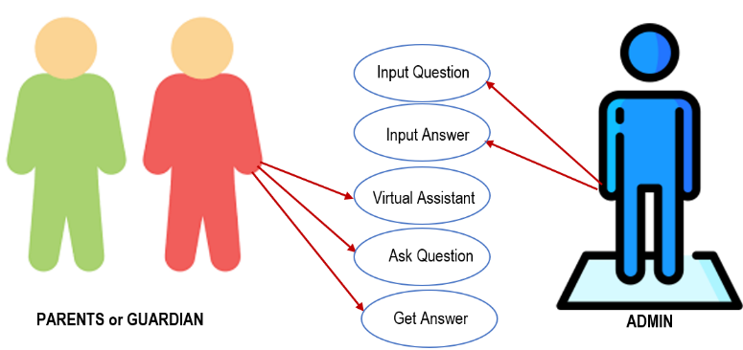

**Figure 3-7.** Use Case Diagram

Figure 3-7 this diagram illustrated how the parents and guardians, along with the admin, can use the mobile virtual assistant app. The admin is the only actor that can input questions and answers in the system’s database in correspondence to the questions. As for the parents or guardians, these users interact with the virtual assistant app through inquiries and in turn, the mobile app gives the parents or guardians a reply in correspondence to inquiries of the parents or guardians.

**System Architecture**. This system architecture includes several components, including the expanded system, all of which are intended to work together to achieve the complete navigation solution. Each component is critical to the system's integration and functionality.

**Figure 3-8.** System Architecture

Figure 3-8 this diagram illustrated how the users, along with the database, interact with the mobile virtual assistant. The mobile virtual assistant processes both text and voice inputs from users, while the database manages bilingual data, supporting interactions in both English and Tagalog.

**Output and User-Interface Design.** The researchers designed an efficient and manageable software system so that new users with little to no prior software experience can be able to navigate and utilize the system with ease.

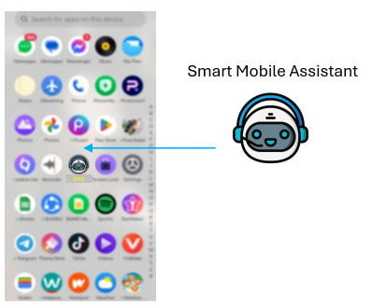

School Virtual Assistant

**Figure 3-9.** Mobile Application

Figure 3-9 is where the majority of users go to, the users that make inquiries regarding the school, school activities, and so on.

**Figure 3-10.** Login

Figure 3-10 is for the users that are managing the system (i.e. Staff and/or Principal), this is the first page that the users can see, here is where the users must enter credentials here.

**Figure 3-11.** Dashboard

Figure 3-11 is the users login, the users are then taken to the dashboard page, this is the overview of the admin site of its contents.

**Figure 3-12.** Questions Page

Figure 3-12 showed the questions page where the administrative users or the staff are able to add, edit, and delete questions that are then reflected in the mobile app.

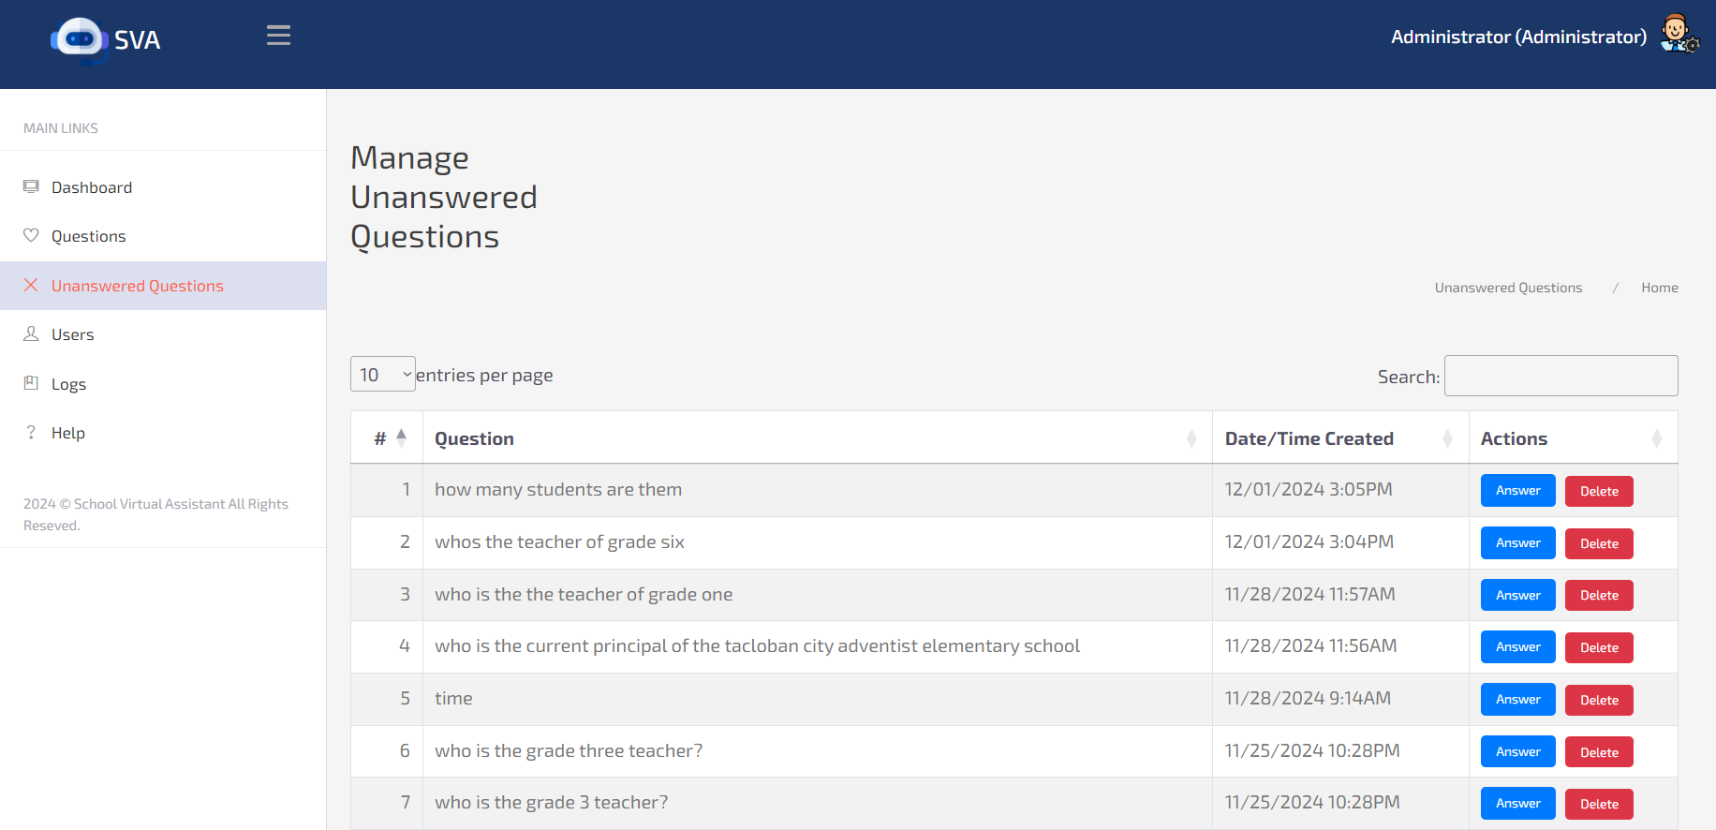

**Figure 3-13.** Unanswered Questions Page

Figure 3-13 showed the unanswered questions page where the staff and/or principal sees questions that are inputted by the users of the mobile that are not yet answered in the admin site.

**Figure 3-14.** Users Page

Figure 3-14 the users page can only be accessed by the administrators; this is where the users can add, edit, and delete users of the admin site.

**Figure 3-15.** Logs Page

Figure 3-15 the logs page as well can only be accessed by the administrators; this is where the admin can see all the activities done throughout the entire admin site.

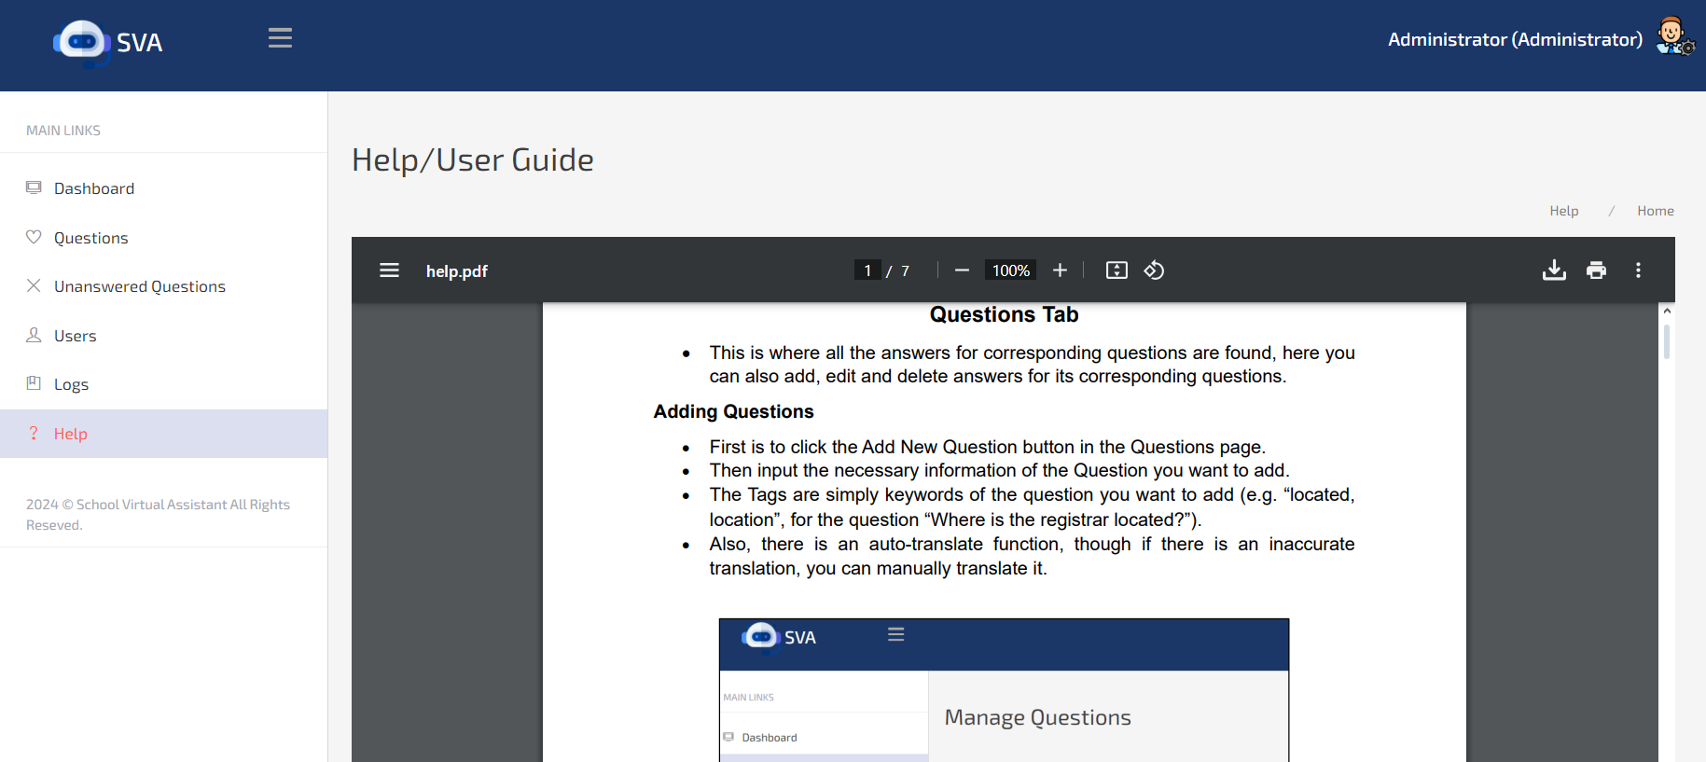

**Figure 3-16.** Help Page

Figure 3-16 for all users of the admin site, this is where the users can find the user manual/guide in managing the admin site.

**Programming Development**

Programming development encompasses the systematic approach in creating programs. This part of the paper addresses the programing environment relevant to the project’s development.

**Programming Environment**

The system was developed using Java for the mobile application, and the admin site of the system was developed using PHP. Java is a programming language well-suited for creating a dynamic and interactive mobile application, the same can be said for PHP in developing web-based systems. Java and PHP was both selected for the various useful features and compatibility. The development was done within the Android Studio and Visual Studio Code environment, both are highly efficient and user-friendly code editors that supports various features for efficient coding. With all of that stated, the development of the system was made far more feasible and easier to develop.

**Web-Based**

**Frontend**

For the development of the frontend of the admin site of the system, the researchers utilized JavaScript for a responsive and visually appealing user interface, ensuring that it blends seamlessly throughout the various devices that the site may be accessed. This firmly established a better user experience and made the admin site easier to navigate.

**Backend**

The backend of the system was developed using PHP as the server-side scripting language, which efficiently handles the admin site’s logic and processes. As to manage and store the system’s data, MySQL was utilized as the database management system, providing a reliable and secure solution for data storage and retrieval.

**Testing**

The system was thoroughly tested to make sure that the requirements were met and to assess its usefulness and efficiency. In order to make sure the system matched user needs and functioned dependably, this procedure required evaluating its performance for both administrative users and the general public.

**Deployment**

During the deployment phase, Tacloban City Adventist Elementary School Inc. is now able to use the designed system. This include setting up servers, setting up required software, and moving the system to a production setting. The researchers offered instructions or documentations required for system operation.

**Evaluation**

The ISO 25010 standards was utilized in evaluating some of the key qualities that project must accomplish. Since ISO 25010 standards provides a comprehensive, structured, and internationally recognized framework. It assesses quality through two models: ProductQuality (technical attributes like functionality, security, and usability) and Quality in Use (user experience and effectiveness) (Peters & Aggrey, 2020). For this project, the data for evaluating the system’s performance was gathered through ISO 25010 standards on functional suitability, performance efficiency, and usability. As the stated three out of the seven standards are far relevant for use in the making of this project (Panduwiyasa, Saputra, Azzahra, & Aniko, 2021). In the evaluation of the system, the researchers utilized a questionnaire based on the three stated ISO 25010 standards and handed the questionnaires to the stakeholders of the project, which was sampled via judgmental sampling. Then the researchers gathered and tallied the results thoroughly. Resulting to means of 4.25 in Functional Suitability, 4.31 in Performance Efficiency, and 4.36 in Usability.

**Chapter IV**

**RESULTS AND DISCUSSIONS**

This showed the results of the objectives of the study as well as how the Virtual Assistant with Speech Recognition with Semiotic Inspection Method using Mobile App has considerably improved the administrative process of Tacloban City Adventist Elementary School’s registrar office.

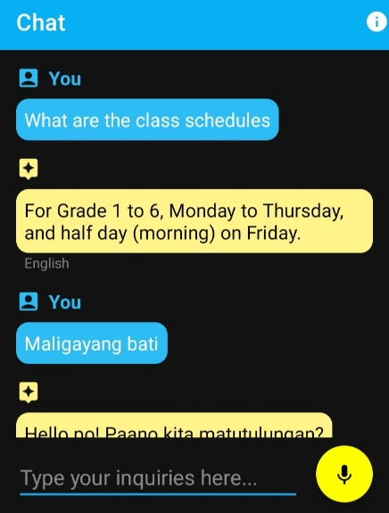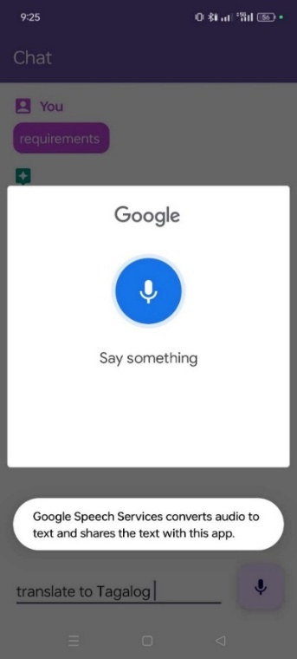**Speech Recognition feature with semiotic inspection method.** Figure 4-1, Speech Recognition means to processes voice inputs to interpret user queries, while semiotic inspection method means to alleviate the communication issues caused by tones and pitches. Fortunately for the researchers, there is a free API offered by Google called: “Speech Recognition and Synthesis”, this API also has a built-in semiotic inspection method, since Google boasts advanced machine learning models to deliver high-quality voice interaction in virtual assistant applications. The researchers utilized Google’s free API by simply integrating it into the mobile app side of the system, to enable the system a language to detection feature, as well as having text-to-speech and speech-to-text features.

**Figure 4-1.** Speech Recognition Feature

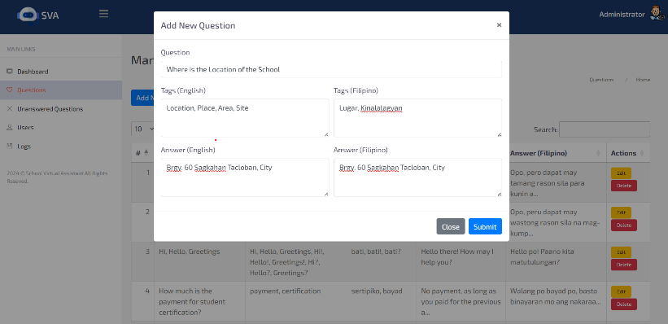**Auto-translate function from English to Tagalog.** In this project, Figure 4-2 showed the auto-translate function of the system, a means to automatically translate the inputs of the admin or staff in adding new questions.The system must be able to translate inquiries from English to Tagalog in real-time, the researchers utilized a node.js plugin called puppeteer, a bot that automates the translation process. The puppeteer plugin simply opens up another browser in the background and opens Google Translate with stated browser, not only that, but puppeteer also monitors the words that the user types in the Tags and Answer field in adding new questions in the admin site, though only in the English side of the Tags and Answer fields, it only auto-translates English to Tagalog.

**Figure 4-2.** Auto-translate Feature

**Language detection function.** In this project, Figure 4-3 language detection means to detect the input language of users. Again, further utilizing the capabilities of Google’s Speech Recognition and Synthesis API, the system is able to detect the language of the users’ inputs.

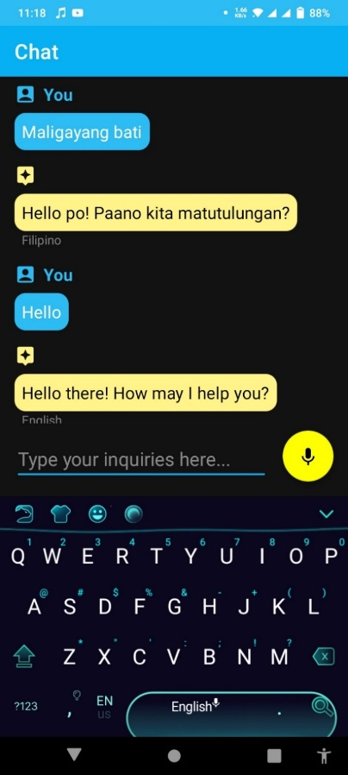

**Figure 4-3.** Language Detection Feature

**System Evaluation Using ISO 25010**

**Table 4-1.** Respondents of the Study

|  |  |
| --- | --- |
| **Respondents** | **No. of Respondents** |
| Principal | 1 |
| Staff | 5 |
| Parents or Guardians | 47 |
| **Total** | **53** |

Table 4-1 showed the researchers conducted a survey questionnaire based on the ISO 25010 standard among 53 respondents, this includes the principal, 5 staff members of the school, and 47 parents or guardians of the children who are enrolled in the school (Peters & Aggrey, 2020).

**Table 4-2.** Functional Suitability of the Mobile Virtual Assistant App

|  |  |  |
| --- | --- | --- |
| **Software Sub-Quality Indicator** | **Values** | **Interpretation** |
| Functional Completeness | 4.1 | Satisfied |
| Functional Correctness | 4.39 | Very Satisfied |
| Grand Mean | 4.25 | Very Satisfied |
| * 4.21 – 5.0 Very satisfied, 3.41 – 4.20 Satisfied, 2.61 – 3.40 Neutral, 1.81 – 2.60 Dissatisfied, 1.0 – 1.80 Very dissatisfied | | |

Table 4-2 illustrated that the system received an overall score of 4.25 in terms of Functional Suitability, which indicates that it effectively meets the key functional requirements set out at the project's inception. This high score suggests that the system performs well in critical areas, particularly in managing inquiries and providing responses in real-time, as was a primary objective. Supported by recent studies, the findings confirm that the system successfully addresses user needs, offering seamless and reliable experience during use. The application operates as intended, demonstrating its robustness and effectiveness in meeting performance expectations and usability standards (Sarwosri, Rochimah, Yuhana, & Hidayat, 2023).

**Table 4-3.** Performance Efficiency of the Mobile Virtual Assistant App

|  |  |  |
| --- | --- | --- |
| **Software Sub-Quality Indicator** | **Values** | **Interpretation** |
| Time Behavior | 4.28 | Very Satisfied |
| Resource Utilization | 4.33 | Very Satisfied |
| Grand Mean | 4.31 | Very Satisfied |
| * 4.21 – 5.0 Very satisfied, 3.41 – 4.20 Satisfied, 2.61 – 3.40 Neutral, 1.81 – 2.60 Dissatisfied, 1.0 – 1.80 Very dissatisfied | | |

Table 4-3 showed the system achieved a score of 4.31 in terms of Performance Efficiency, reflecting its strong capability to process inquiries swiftly and efficiently, thereby minimizing delays and significantly enhancing overall administrative workflows. This performance aligns with the study's goals to deliver reliable, high-quality functionality, ensuring that the application supports seamless and effective operations. The high score further underscores the app's ability to meet expected performance standards, with efficient processing and responsiveness that contribute to optimal user experience and streamlined administrative processes (Arellano Jr. & Villarica, 2024).

**Table 4-4.** Usability of the Mobile Virtual Assistant App

|  |  |  |
| --- | --- | --- |
| **Software Sub-Quality Indicator** | **Values** | **Interpretation** |
| Operability | 4.39 | Very Satisfied |
| User Error Protection | 4.33 | Very Satisfied |
| Grand Mean | 4.36 | Very Satisfied |
| * 4.21 – 5.0 Very satisfied, 3.41 – 4.20 Satisfied, 2.61 – 3.40 Neutral, 1.81 – 2.60 Dissatisfied, 1.0 – 1.80 Very dissatisfied | | |

Table 4-4 showed that the system scored 4.36 in terms of Usability, the system demonstrated a high level of user-friendliness for both staff and parents/guardians, who found the interface intuitive and easy to navigate. This feedback is supported by recent studies indicating that users were able to locate information effortlessly and complete tasks without errors or technical issues. The streamlined navigation and accessible design allowed users to interact with the system efficiently, confirming its effectiveness in providing a smooth and straightforward user experience. This ease of use is essential in fostering user satisfaction and supporting the system’s overall functionality (De los Santos, Batan, & De los Santos, 2020).

Furthermore, apart from the ISO 25010-based quantitative analysis of the performance of the app, we did qualitative assessments involving user interviews and surveys. This helped demonstrate in-depth, real-world scenarios for how the system performs. In the interviews, users disclosed the usage experience of the system, including good characteristics such as usability and fast response time, while insisting on improvement in the ability to address more complex queries. The surveys confirmed these findings since about 85% of users perceived the system was satisfactory or better in terms of ease of use, and about 86% stated that using the app had enabled them to achieve greater efficiency in the academic tasks. This still allowed the respondents to rate different aspects of the system while giving comprehensive feedback regarding the system’s influence on daily tasks. This allows for a more comprehensive view of the app, beyond high ratings of satisfaction, towards practical usage benefits and challenges that it may pose.

Additionally, issues with user pronunciation and language limitations were resolved by combining speech recognition with semiotic inspection. The technology helped non-native speakers and users with accents communicate by using speech processing and real-time translations. Even with misspelled or grammatically wrong inquiries, responses could be sent because to the keyword identification feature, which significantly improved system accuracy.

**Chapter V**

**SUMMARY, CONCLUSIONS, AND RECOMMENDATIONS**

This section comprises a summary, conclusion, and recommendations for the Virtual Assistant with Speech Recognition with Semiotic Inspection Method using Mobile App designed for Tacloban City Adventist Elementary School’s registrar office. The summary delineated the system’s findings, while the conclusion is derived from the study’s objectives and the system’s implementation performance. The recommendations put forth potential enhancements and provide guidelines for future improvements.

**Summary**

The system utilized many advanced technologies like Google's Speech Recognition and Synthesis API, and a plugin called Puppeteer. The main goals of utilizing stated technologies are to attain the project’s objectives. The system also underwent evaluation under the 25010 Standards.

In attaining the objective of implementing a speech recognition feature with semiotic inspection method, the researchers integrated into the system the Speech Recognition and Synthesis API from Google. The API from Googe proved itself effective and reliable in the testing phase, up until the full release of the system and is most likely would still be utilized in the future. As based from feedback from the stakeholders/users who took part in the testing phase who were interviewed for comments about the feature/API. Many of the stakeholders/users had similar comments about the feature, many stated that the feature was not only easy to navigate, but it was also quick or straightforward, and it gave better convenience in using the system.

In attaining the objective of implementing an auto-translate function from English to Tagalog, the researchers implemented a plugin called Puppeteer, a plugin that allows the automation of the translation process in the admin side of the system. Puppeteer opens a browser in the background that then opens Google Translate, and from there, Puppeteer then monitors what the user types in the Tags & Answer field in the admin site when adding or editing questions, allowing the system to have an auto-translate feature in the admin site. Based from the feedback of the stakeholders/users that were interviewed for comments on the feature, many had similar comments, stating that it was very unique and is very convenient.

In attaining the objective of implementing a language detection feature in the system, the researchers integrated into the system the Speech Recognition and Synthesis API from Google. Showing the potential and reliability of Google’s Speech Recognition and Synthesis, the researchers utilized Google’s API again into the system for this certain objective, enabling the system a language detection feature that allows it to discern the language of the users’ voice and text input. And based on the comments of the stakeholders/users, this feature proved to be quick or straightforward and convenient.

In attaining the objective of evaluating the system using ISO 25010 software standards, the researchers created a questionnaire based from the three ISO 25010 standards, which are: functional suitability, performance efficiency, and usability. As the three standards are far more relevant than the other standards for this project, this action was based on the judgment of the researchers and similar preceding studies. The researchers then handed the questionnaires out to the stakeholders/users, and then the researchers gathered and tallied the results of the stakeholders/users based on the questionnaire.

**Conclusions**

With the integration of Google’s Speech Recognition and Synthesis API into the mobile app side of the system as a means to attain the objective of having a speech recognition feature with semiotic inspection method, it proved to be effective and reliable, and in conclusive words of the stakeholders/users based on comments on the feature, it is quick or straightforward and is quite convenient.

With the integration of the Puppeteer Plugin and with the help of Google Translate on the admin side of the system, the system is able to attain the objective of auto-translate function from English to Tagalog. The Puppeteer plugin is only used for automation, not translation, meaning it only monitors the inputs from the users in the Tags & Answer field in the admin site, and takes the inputs of the users into Google Translate, then takes the translated inputs back to the admin site. Google Translate is only used in the translation process, as Google Translate is known to be accurate and reliable. In conclusion, this feature present in the system gave the stakeholders/users the impression that it is very convenient and quite unique.

With the integration of Google’s Speech Recognition and Synthesis API on the mobile app side of the system, it attains the objective of implementing a language detection feature in the system. By integrating this API, it further enhanced the convenience and overall functionality of the system, with comments from the stakeholders/users that it is straightforward and convenient.

In the results of the evaluation using the three ISO 25010 software standards, it showed the exceptional performance of the system with a score of 4.25 for functional suitability, which is interpreted as Very Satisfied. As for performance efficiency, a score of 4.31 was the tallied mean, being interpreted as Very Satisfied, again showing its exceptional performance in that field. And lastly, a score of 4.36 was the tallied mean for usability, which is interpreted as Very Satisfied, the results overall point towards the idea that the system is solid and is up to standards. The Mobile App at Tacloban City Adventist Elementary School promises far-reaching applications and further improvements to educational systems and inquiry services. It has positively heightened the efficacy levels of using the service while elevating the user's satisfaction level and lessening the burden of the administration.

**Recommendations**

For further improvement in both the user and admin side of the system, some recommendations have been proposed including:

Extend Platform Support: In the coming versions, iOS should be supported to create a wider reach for the system.

Long-term assessment: A long-term assessment of the system's impact on administrative efficiency and user satisfaction could be done to identify areas for improvement.

# REFERENCES

Abougarair, A. J., Aburakhis, M. K., & Zaroug, M. O. (2022, February 24). *Design and implementation of smart voice assistant.* Retrieved from Research Gate: https://www.researchgate.net/profile/Ahmed-Abougarair/publication/358854118_Design_and_implementation_of_smart_voice_assistant_and_recognizing_academic_words/links/6218d8ab9947d339eb6893fd/Design-and-implementation-of-smart-voice-assistant-and-recognizing

Adamopoulou, E., & Moussiades, L. (2020, December 15). *Chatbots: History, technology, and applications.* Retrieved from ScienceDirect: https://www.sciencedirect.com/science/article/pii/S2666827020300062

Agarwal, S., Agarwal, B., & Gupta, R. (2022). *Chatbots and virtual assistants: A bibliometric analysis.* Retrieved from Emeral Insight: https://www.emerald.com/insight/content/doi/10.1108/LHT-09-2021-0330

Alliance, A. (2024). *Agile Alliance*. Retrieved from Agile Alliance: https://www.agilealliance.org/

Althobaiti, M. (2022). *BERT-based Approach to Arabic Hate Speech and Offensive Language Detection in Twitter: Exploiting Emojis and Sentiment Analysis.* Retrieved from ProQuest: https://www.proquest.com/openview/0a27f67d91c220435bf1785156b50edb/1?pq-origsite=gscholar&cbl=5444811

Arellano Jr., A., & Villarica, M. (2024). *Community-Based Welfare Services System: Utilizing Machine Learning with Data Visualization to Improve Access and Service Delivery*. Retrieved from UIJRT: https://uijrt.com/articles/v5/i6/UIJRTV5I60016.pdf

Ben Lutkevich. (2021, September 13). *techtarge*. Retrieved from www.techtarget.com: https://www.techtarget.com/searchcustomerexperience/definition/speech-recognition

BEng(Hons), D. F. (2024, September 5). *Speech Processing*. Retrieved from sciencedirect: https://www.sciencedirect.com/topics/engineering/speech-processing?fbclid=IwZXh0bgNhZW0CMTEAAR26eVKrAGt0bQcqtRdae5MGPN9RVbT70olK_2mSfc8L7Y5y785tUi2Mq-I_aem_CpXIGm02m-vYtgHssOz9Lw

Chowdhary, K. (2020). *Natural language processing.* Retrieved from Springer Link: https://link.springer.com/chapter/10.1007/978-81-322-3972-7_19

Cole Stryker, J. H. (2024, August 11). *Natural Language Processing*. Retrieved from IBM: https://www.ibm.com/topics/natural-language-processing?fbclid=IwZXh0bgNhZW0CMTEAAR1u26D6KJN5Opb04ZCIX5UccoGzOkLVIWrszooZbD-chwayn9qgqlrEIfE_aem_t-nJ_zU2gcj6Ufi0wvrf6A

Dall’Acqua, A., & Bellentani, F. (2023). *How to build a chatbot. A semiotic and linguistic approach.* Retrieved from IRIS AperTO Universita de Torino: https://iris.unito.it/handle/2318/1908950

De los Santos, J., Batan, M., & De los Santos, G. (2020). *Web App Voting System in a Philippine State University: An ISO 9241–11 Evaluation*. Retrieved from IEEE: https://scholar.google.com/scholar?hl=en&as_sdt=0%2C5&q="Web+app+voting+system+in+a+Philippine+State+University%3A+An+ISO+9241-11+Evaluation&btnG=

de Souza, C. S. (2001). A semiotic inspection method for evaluating user-interface languages. *International Journal of Human-Computer Studies*, 54(4), 415-452.

Duguleană, M., Briciu, V.-A., Duduman, I.-A., & Machidon, O. (2020, August 26). *A Virtual Assistant for Natural Interactions in Museums.* Retrieved from MPDI: https://www.mdpi.com/2071-1050/12/17/6958

Essel, H., Vlachopoulos, D., Tachie‑Menson, A., Johnson, E., & Baah, P. (2022). *The impact of a virtual teaching assistant.* Retrieved from Springer: https://link.springer.com/article/10.1186/s41239-022-00362-6

Han, S., & Lee, M. (2022, April). *FAQ chatbot and inclusive learning in massive open online courses.* Retrieved from ScienceDirect: https://www.sciencedirect.com/science/article/abs/pii/S0360131521002724

Jampala, R., Kola, D., Gummadi, A., Bhavanam, M., & Pannerselvam, I. (2024, January). *The Evolution of Voice Assistants: From Text-to-Speech to Conversational AI*. Retrieved from IEEE Xplore: https://ieeexplore.ieee.org/abstract/document/10467739

Kenton, B. W. (2024, May 10). *investopedia*. Retrieved from www.investopedia.com: https://www.investopedia.com/terms/v/virtual-assistant.asp

Kolhar, M., & Alameen, A. (2021, January 23). *Artificial Intelligence Based Language Translation Platform.* Retrieved from Tech Science: https://cdn.techscience.cn/ueditor/files/TSP_IASC-28-1/TSP_IASC_14995/TSP_IASC_14995.pdf

Koli, A., Khatter, K., Singh, S., & Kurana, D. (2022, July 14). *Natural language processing: state of the art, current trends and challenges.* Retrieved from Springer Link: https://link.springer.com/article/10.1007/s11042-022-13428-4

Kumar, R., Gupta, M., Shrama, P., Soni, N., & Rawat, K. (2024, March 19). *NLP-Based text-to-speech and speech-to-text virtual assistant* . Retrieved from AIP Publishing: https://pubs.aip.org/aip/acp/article-abstract/3072/1/020031/3277795/NLP-Based-text-to-speech-and-speech-to-text

Kumari, S., Naikwadi, Z., Akole, A., & Darshankar, P. (2020, July). *Enhancing college chat bot assistant with the help of richer human computer interaction and speech recognition.* Retrieved from IEEE Xplore: https://ieeexplore.ieee.org/abstract/document/9155951

Lauriola, I., Lavelli, A., & Aiolli, F. (2022, January). *An introduction to deep learning in natural language processing: Models, techniques, and tools.* Retrieved from ScienceDirect: https://www.sciencedirect.com/science/article/pii/S0925231221010997

Lenovo. (2024, May 7). *Tags*. Retrieved from lenovo.com: i.e. meaning

Li, C., Kim, H., Park, J., & Chrysostomou, D. (2021, March 8). *How can I help you? An Intelligent Virtual Assistant for Industrial Robots.* Retrieved from ACM Digital Library: https://dl.acm.org/doi/abs/10.1145/3434074.3447163

Li, H., & Yang, Y. (2022, November). *Keyword targeting optimization in sponsored search advertising: Combining selection and matching.* Retrieved from Science Direct: https://l.messenger.com/l.php?u=https%3A%2F%2Fwww.sciencedirect.com%2Fscience%2Farticle%2Fpii%2FS1567422322000928&h=AT2H5qxB4PHY0qWXs3CXl28ACyka3xjVumTRygq5yqBUHcYEYAvLiq6LzNKhHGAkKD9_-yic0SSVsBvZl7tXRLBZS3QIWra-DFceKnft77j2MlUY4670jXalTK5ggFeyCBH1LQ

Manning, C. D. (2008). Introduction to information retrieval. Cambridge University Press.

Maylawati, D., Risqiati, A., Slamet, C., Ramdhani, M., Lukman, N., Dauni, P., & Arianti, N. (2022, January 6). *Chatbot for Virtual Travel Assistant with Random Forest and Rapid Automatic Keyword Extraction.* Retrieved from IEEE Xplore: https://ieeexplore.ieee.org/abstract/document/9664876/authors#authors

Mehrish, A., Majumder, N., Bharadwaj, R., Mihalcea, R., & Poria, S. (2023, November). *A review of deep learning techniques for speech processing.* Retrieved from ScienceDirect: https://www.sciencedirect.com/science/article/abs/pii/S1566253523001859

Mekni, M., Baani, Z., & Sulieman, D. (2020, February 17). *A Smart Virtual Assistant for Students.* Retrieved from ACM Digital Library: https://dl.acm.org/doi/abs/10.1145/3378184.3378199

*Merriam-Webster*. (2024, July 7). Retrieved from Merriam-Webster.com dictionary.: https://www.merriam-webster.com/dictionary/inquire

Muhtar, R., Gerhana, Y., Maylawati, D., Slamet, C., Alam, C., Darmalaksana, W., & Ramdhani, M. (2021, January 12). *Multinomial Naïve Bayes and Rapid Automatic Keywords Extraction for Taharah (Purify) Law Chatbot.* Retrieved from European Union Digital Library: https://eudl.eu/doi/10.4108/eai.11-7-2019.2298028

Nations, D. (2024, April 17). *Lifewire.* Retrieved from lifewire.com: https://www.lifewire.com/define-tagging-3486207

Onyalo, W. A. (2022). *Ai Chatbot: Improve Efficiency in Handling Student Queries at the Department of Computing and Informatics, Nairobi University (Doctoral dissertation, university of nairobi).* Retrieved from University of Nairobi Research Archive: http://erepository.uonbi.ac.ke/handle/11295/161598

Panduwiyasa, H., Saputra, M., Azzahra, Z., & Aniko, A. (2021). *Accounting and Smart System: Functional Evaluation of ISO/IEC 25010:2011 Quality Model (a Case Study)*. Retrieved from IOP Science: https://iopscience.iop.org/article/10.1088/1757-899X/1092/1/012065/meta

Peters, E., & Aggrey, G. (2020). *An ISO 25010 Based Quality Model for ERP Systems.* Retrieved from Semantic Scholar: https://www.semanticscholar.org/paper/An-ISO-25010-Based-Quality-Model-for-ERP-Systems-Peters-Aggrey/d0bcf28564319cb40a77a04da5ed7e1f285894f4?p2df

Registrar., V. (. (2024, July 7). *Registrar.* Retrieved from Vocabulary.com Dictionary.: https://www.vocabulary.com/dictionary/registrar

Sarwosri, S., Rochimah, S., Yuhana, U., & Hidayat, S. (2023). *Software Quality Measurement for Functional Suitability, Performance Efficiency, and Reliability Characteristics Using Analytical Hierarchy Process*. Retrieved from JOIV: https://joiv.org/index.php/joiv/article/view/2441

Sharabi, C. (2023, September 5). *Auto-Translate*. Retrieved from Blend: https://www.getblend.com/blog/what-is-automatic-translation/?fbclid=IwZXh0bgNhZW0CMTEAAR2jFPEAq_EEoWcd0RPYbZ9FrZ20jOxLaUy9BgKPR5BFNPUOGbUYz0_6NTk_

Srinam. (2024, January 31). *Keyword Matching*. Retrieved from geeksforgeeks: https://www.geeksforgeeks.org/keyword-searching-algorithms-for-search-engines/?fbclid=IwZXh0bgNhZW0CMTEAAR3z1U8gwfP30Wy_Q8SrBhbZ-8hSFmq7BsGn78CihzKuioXpS-qM952pH6E_aem_sKy0n7uizClpS2xgYTHIvA

Taherdoost, H. (2021). *Sampling Methods in Research Methodology; How to Choose a Sampling Technique for Research.* Retrieved from HAL: https://hal.science/hal-02546796/

*theknowledgeacademy*. (2023, November 30). Retrieved from www.theknowledgeacademy.com: https://www.theknowledgeacademy.com/blog/what-is-android/

Turner, S. (2024). Application: A class of software specifically designed to perform various tasks and functions for end-users. *Journal of Mobile Technology,V*, 8(2), 45-58.

Valtolina, S., Barricelli, B., & Di Gaetano, S. (2020). *Communicability of traditional interfaces VS chatbots in healthcare and smart home domains.* Retrieved from Taylor and Francis Online: https://www.tandfonline.com/doi/abs/10.1080/0144929X.2019.1637025

Villegas-Ch, W., Garcia-Ortiz, J., Mullo-Ca, K., Sánchez-Viteri, S., & Roman-Cañizares, M. (2021, April 13). *Implementation of a Virtual Assistant for the Academic Management of a University with the Use of Artificial Intelligence.* Retrieved from MPDI: https://www.mdpi.com/1999-5903/13/4/97

Wang, M. (2020). *Linguistic semiotics.* Retrieved from Springer: https://link.springer.com/content/pdf/10.1007/978-981-15-3246-7.pdf

Yellamma, P., Varun, P., Narayana, N., Chowdary, Y., Manikanth, P., & Sai, K. (2024). *Automatic and Multilingual Speech Recognition and Translation by using Google Cloud API*. Retrieved from IEEE Xplore: https://ieeexplore.ieee.org/abstract/document/10493971

Zhang, R., Zou, D., & Cheng, G. (2023, April 19). *A review of chatbot-assisted learning: pedagogical approaches, implementations, factors leading to effectiveness, theories, and future directions.* Retrieved from Taylor & Francis Online: https://www.tandfonline.com/doi/abs/10.1080/10494820.2023.2202704

**APPENDIX A**

**LETTER TO CLIENT**

**APPENDIX B**

**EVALUATION TOOL**

**SURVEY QUESTIONNAIRE**

(Based on ISO 25010 Software Quality Standard)

Rating Scale:

5 – Very satisfied, 4 – Satisfied, 3 – Neutral, 2 – Dissatisfied, 1 – Very dissatisfied

*4.21 – 5.0 Very satisfied, 3.41 – 4.20 Satisfied, 2.61 – 3.40 Neutral, 1.81 – 2.60 Dissatisfied, 1.0 – 1.80 Very dissatisfied

**Functional Suitability**

|  |  |  |  |  |  |
| --- | --- | --- | --- | --- | --- |
| Questions | 5 | 4 | 3 | 2 | 1 |
| **Functional Completeness** |  |  |  |  |  |
| 1. The virtual assistant chatbot meets the functional requirements as specified. |  |  |  |  |  |
| 1. I am satisfied with how well the chatbot performs all the functions described in the user documentation. |  |  |  |  |  |
| **Functional Correctness** |  |  |  |  |  |
| 1. I am satisfied with the accuracy of the responses provided by the virtual assistant chatbot. |  |  |  |  |  |
| 1. The results and actions of the chatbot align with my expectations. |  |  |  |  |  |
| 1. Overall, I am satisfied with the functionality of the software. |  |  |  |  |  |

**Performance Efficiency**

|  |  |  |  |  |  |
| --- | --- | --- | --- | --- | --- |
| Questions | 5 | 4 | 3 | 2 | 1 |
| **Time Behavior** |  |  |  |  |  |
| 1. I am satisfied with the response time of the virtual assistant chatbot. |  |  |  |  |  |
| 1. The processing times of the chatbot are reasonable for my needs. |  |  |  |  |  |
| **Resource Utilization** |  |  |  |  |  |
| 1. The amount of system resources consumed by the chatbot is acceptable. |  |  |  |  |  |
| 1. I am satisfied with the chatbot’s performance under high usage conditions. |  |  |  |  |  |
| 1. Overall, I am satisfied with the efficiency of the software. |  |  |  |  |  |

**Usability**

|  |  |  |  |  |  |
| --- | --- | --- | --- | --- | --- |
| Questions | 5 | 4 | 3 | 2 | 1 |
| **Operability** |  |  |  |  |  |
| 1. I am satisfied with how easy it is to operate and navigate the virtual assistant chatbot. |  |  |  |  |  |
| 1. I am satisfied with the intuitive design of the chatbot’s interface. |  |  |  |  |  |
| **User Error Protection** |  |  |  |  |  |
| 1. I am satisfied with how well the virtual assistant chatbot helps prevent user errors. |  |  |  |  |  |
| 1. The chatbot provides useful feedback when errors occur. |  |  |  |  |  |
| 1. Overall, I am satisfied with the Usability of the software. |  |  |  |  |  |

**APPENDIX C**

**EVALUATION RESULTS**

1. Functional Suitability

|  |  |  |
| --- | --- | --- |
| **Software Sub-Quality Indicator** | **Values** | **Interpretation** |
| Functional Completeness | 4.1 | Satisfied |
| Functional Correctness | 4.39 | Very Satisfied |
| Grand Mean | 4.25 | Very Satisfied |
| * 4.21 – 5.0 Very satisfied, 3.41 – 4.20 Satisfied, 2.61 – 3.40 Neutral, 1.81 – 2.60 Dissatisfied, 1.0 – 1.80 Very dissatisfied | | |

The system received a score of 4.25, indicating that it effectively meets the functional requirements, particularly in managing inquiries and providing responses in real-time.

1. Performance Efficiency

|  |  |  |
| --- | --- | --- |
| **Software Sub-Quality Indicator** | **Values** | **Interpretation** |
| Time Behavior | 4.28 | Very Satisfied |
| Resource Utilization | 4.33 | Very Satisfied |
| Grand Mean | 4.31 | Very Satisfied |
| * 4.21 – 5.0 Very satisfied, 3.41 – 4.20 Satisfied, 2.61 – 3.40 Neutral, 1.81 – 2.60 Dissatisfied, 1.0 – 1.80 Very dissatisfied | | |

With a score of 4.31, the system demonstrated its ability to process inquiries promptly, minimizing delays and enhancing overall administrative processes.

1. Usability

|  |  |  |
| --- | --- | --- |
| **Software Sub-Quality Indicator** | **Values** | **Interpretation** |
| Operability | 4.39 | Very Satisfied |
| User Error Protection | 4.33 | Very Satisfied |
| Grand Mean | 4.36 | Very Satisfied |
| * 4.21 – 5.0 Very satisfied, 3.41 – 4.20 Satisfied, 2.61 – 3.40 Neutral, 1.81 – 2.60 Dissatisfied, 1.0 – 1.80 Very dissatisfied | | |

Scoring 4.36, the system proved user-friendly for both staff and parents/guardians, who found the interface intuitive and easy to navigate.

**APPENDIX D**

**ACCEPTANCE SHEET**

**

**APPENDIX E**

**USERS GUIDE/MANUAL**

1. **Administrator**
2. Upon entering the admin site, administrator are prompted to log in to ensure security and data integrity.

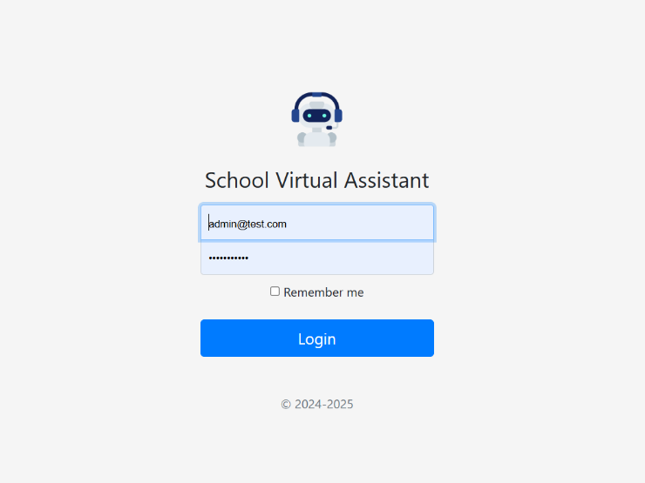

1. 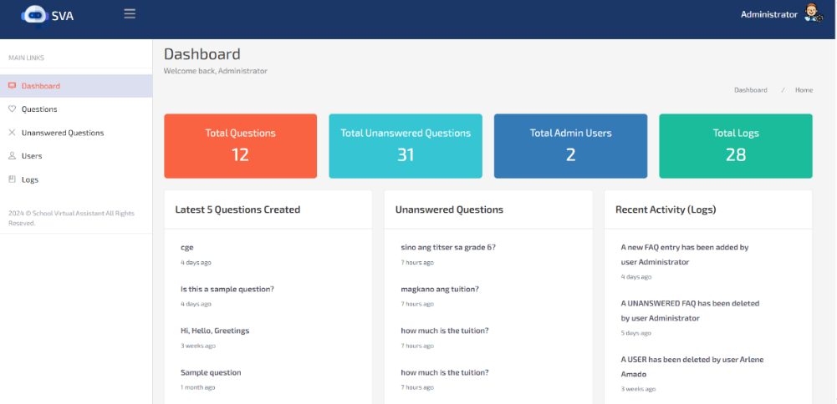Once logged in, the users are greeted by a comprehensive metrics: the total number of questions processed, the number of unanswered questions, the count of registered admin users, and logs that tract system activities. The left sidebar offers intuitive navigation to essential section, including questions, unanswered questions, users, and Logs.

# In the Question section, administrators can input new inquiries, focusing on registrar- related topics. Each question should be tagged appropriately in both English and Tagalog.

1. 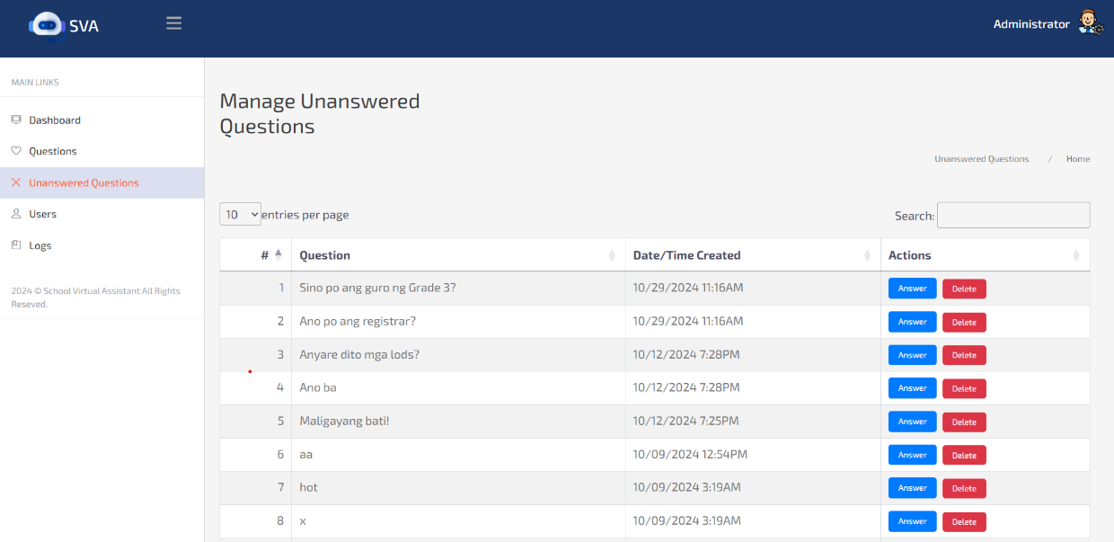In the Unanswered Question Section, admins can manage queries that require attention.
2. 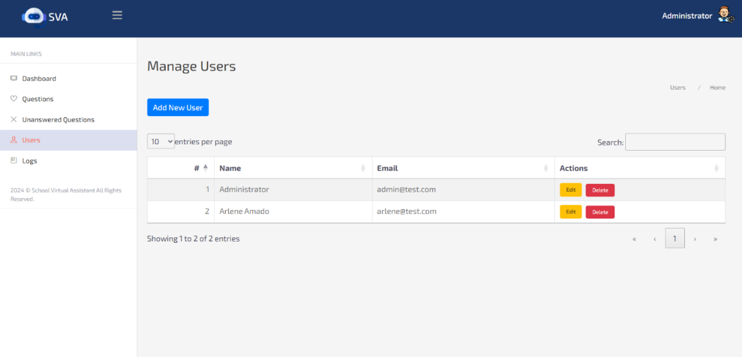In the User Section, allowing for addition and deletion of users as necessary.
3. The Logs section provides a detailed history of system interactions, enabling administrator to track user engagement and identify trends or issues.

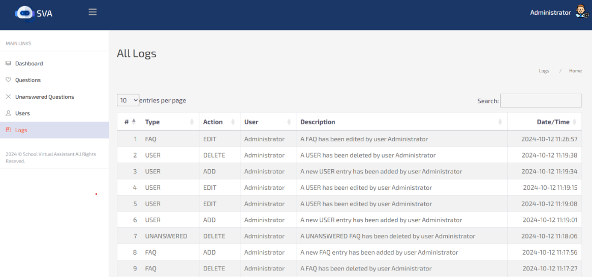

1. **Parents/Guardians**
2. In the mobile app, parents and guardians are equipped with two primary methods for interactions: a text input field for typing questions and a voice/speech recognition feature for hands-free inquires.

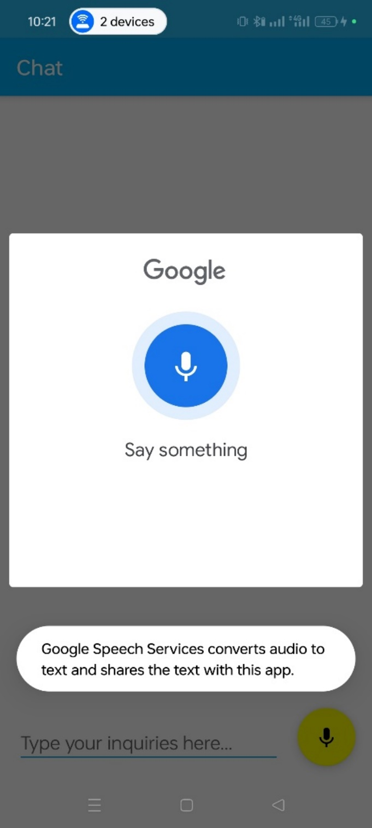

1. 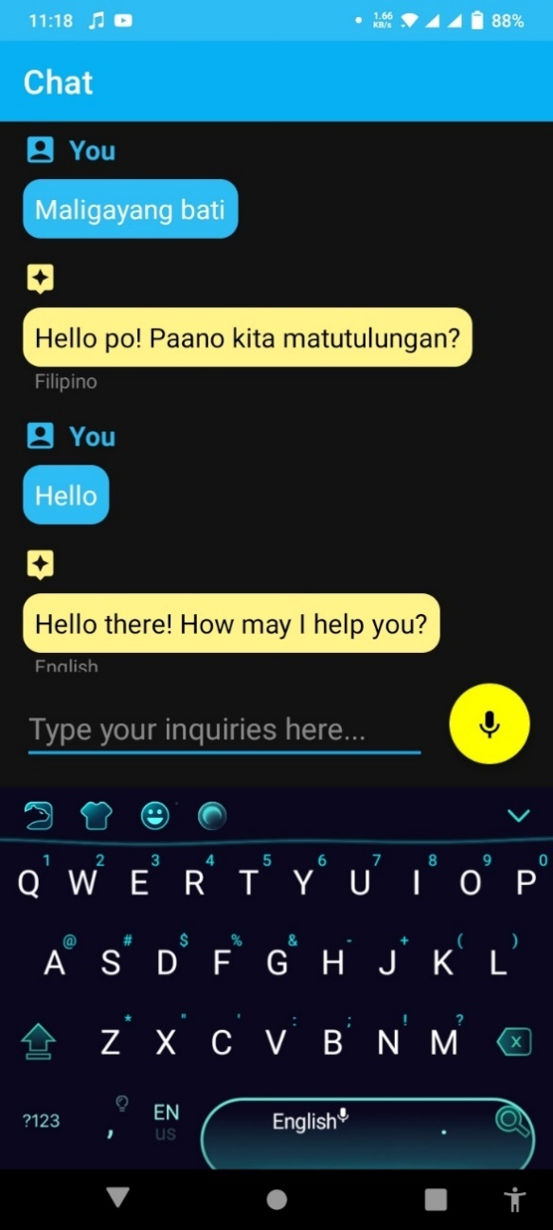In mobile app, when parents or guardians enquire in Tagalog, the users receive replies in Tagalog. Similarly to English. But if it is mixed English & Tagalog, the app replies in English.

**APPENDIX F**

**TURNITIN CERTIFICATE**

**INFORMATION TECHNOLOGY DEPARTMENT**

Certificate of Similarity Index

This is to certify that the Capstone Project entitled:

**VIRTUAL ASSISTANT WITH SPEECH RECOGNITION WITH SEMIOTIC INSPECTION METHOD USING MOBILE APP**

authored by:

**Arlene P. Amada  
Jason Joseph P. Holanda**

**Ritze. M. Lianza**

*Bachelor of Science in Information Technology*

has been subjected to similarity check on February 27, 2025

with a generated Similarity Index of **12%**

Certified true and correct:

**Giovanni N. de los Santos**

Capstone Project Adviser

Noted:

**Lyra K. Nuevas**

Capstone Project Instructor

**CURRICULUM VITAE**



**CURRICULUM VITAE**



**CURRICULUM VITAE**

